**CAR REPAIR BOOKING WEBSITE**

User Manual

SASIK SERVICE STATION

Version 1.0

Contents

Getting Started 3

Accessing the Website 3

Navigating to the Booking Page 3

Booking a Service 4

Filling Out the Booking Form 4

Confirmation of Booking 7

Navigating the FAQs Page 8

Open the FAQs Page 8

Find Your Answer 8

Navigating the Contact Us Page 9

Open the Contact Us Page 9

Find Contact Details 9

Use the Map for Directions 11

How to Cancel a Booking 11

# Getting Started

## Accessing the Website

* Open a web browser (Chrome, Firefox, Safari, Edge).
* Enter the website URL: <https://sasik-car-care.vercel.app/>
* The homepage will display available services and general information

# Navigating to the Booking Page

* To book a service, click on the **"BOOKING"** tab in the navigation menu.
* This will take you to the Booking Page, where you can schedule your car service.

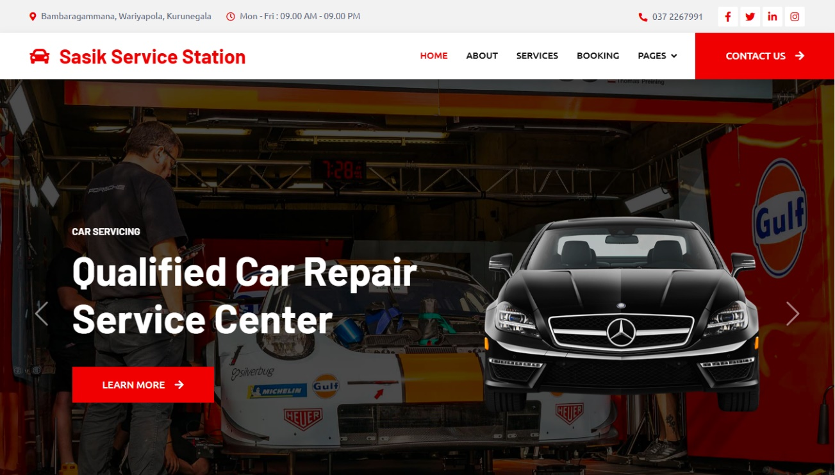

# Booking a Service

## Filling Out the Booking Form

On the **Booking Page**, follow these steps:

1. Enter Your Name

Type your full name in the provided input field.



1. Enter Your Email

Provide a valid email address for confirmation.



1. Select A Service

Click the dropdown menu and choose the desired car service.

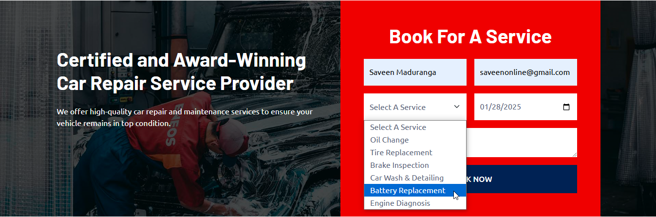

1. Choose a Date

Click the date picker and select a preferred appointment date.

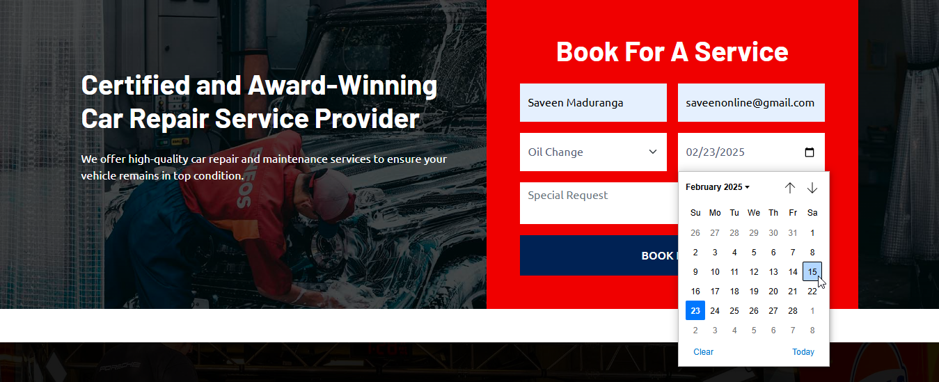

1. Enter Special Request (Required)

You must enter any specific details or requests regarding your service



1. Click "BOOK NOW"

Once all fields are completed, click the button to submit your request.



## Confirmation of Booking

1. If your booking is successful, you will see a notification message:

A pop-up will appear with the message:  
**"Booking submitted successfully!"**

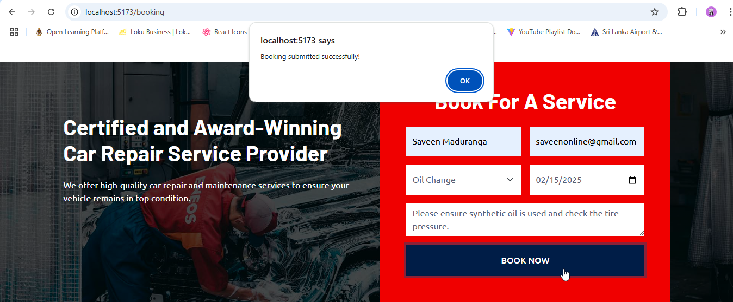

1. **Click "OK"** to complete the booking process.



1. If the booking fails, you will see an error popup:

**"Failed to submit booking."**

Please recheck your form and try again.

# Navigating the FAQs Page

## Open the FAQs Page

Click on the **"FAQs"** link in the footer.

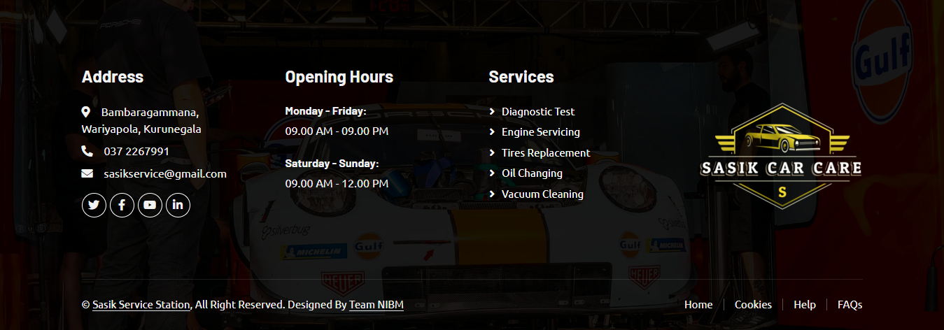

## Find Your Answer

Browse common questions, such as:

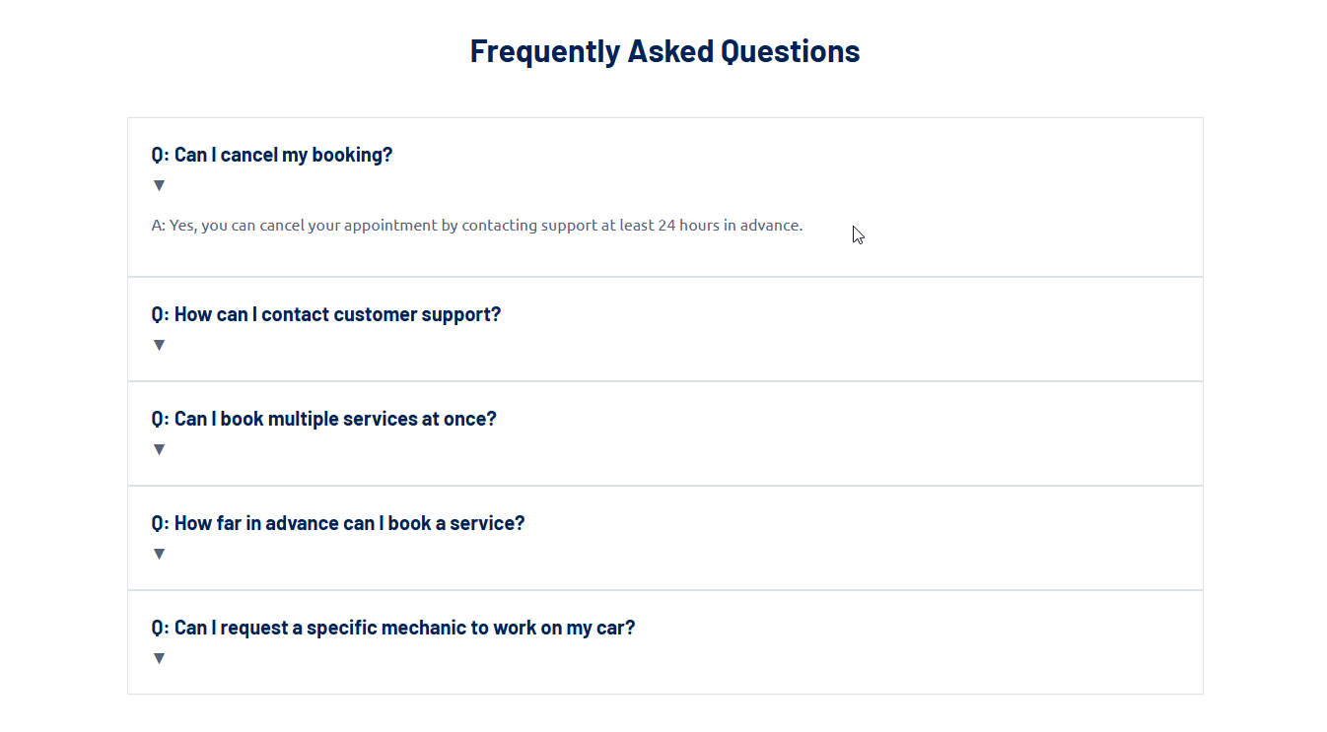

If your question is not listed, proceed to the Contact Us page.

# Navigating the Contact Us Page

## Open the Contact Us Page

Click the **“Contact Us”** link in the navigation menu.

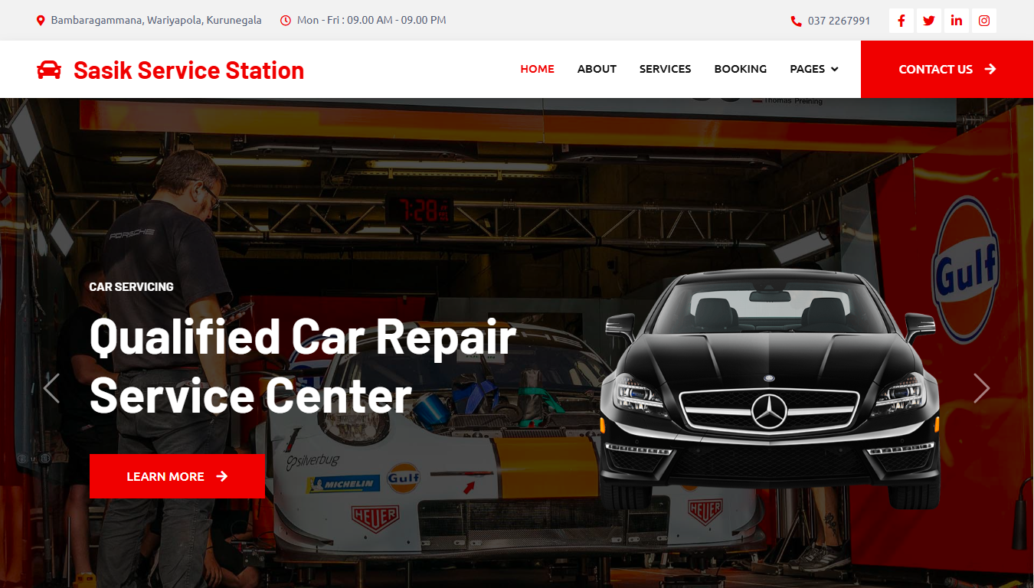

## Find Contact Details

Email address

You can reach us through our contact page, via email at [sasikservice@gmail.com](mailto:sasikservice@gmail.com).

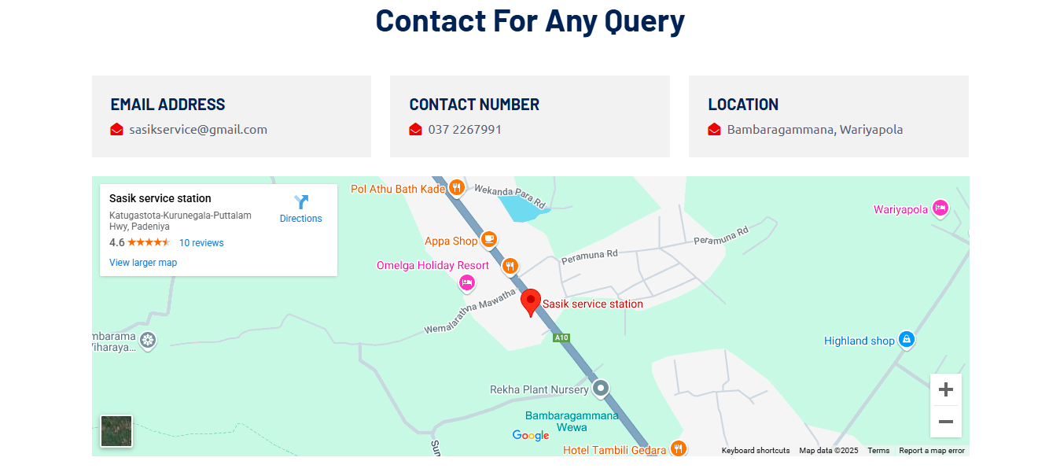

Contact Number

You can reach us through our contact page, by calling our support number.



Location



## Use the Map for Directions



# How to Cancel a Booking

Go to the Contact Us Page

Request a Cancellation

* Call Support: 037 2267991
* Email Support: sasikservice@gmail.com
* Ensure you request cancellation at least 24 hours before your appointment.